**CHAPTER 1**

**INTRODUCTION**

**1.1 Background:**

Hospitals deal with the life and health of their patients. Good medical care relies on well-trained doctors and nurses and on high quality facilities and equipment. Good medical care also relies on good record keeping. Without accurate, comprehensive and up to date and accessible patient notes, medical personnel may not offer the best treatment or may in fact misdiagnose the condition, which can have serious consequences.

Record keeping is an important aspect of every organizations/ institution’s day to day operations. There cannot be a records management system without records and neither can there be efficient record keeping without a good records management system. Therefore, record keeping is the Systematic procedure by which the records of an organization are created, captured, maintained, and disposed of.

Records Management as a discipline involves records keeping. Records Management refers to an on-going process of managing the records in a media neutral basis in accordance with approved policies, procedures and schedules.

Patients Records Management System is a system that aims to keep track of all the patients’ records and be accessed with ease. This will help to improve ways in which services are rendered to patients by increasing efficiency and educing time taken to deliver services. Patient Records Management system provides with the function to create, retrieve and disposition of patients records in hospital. This system ensures their preservation for evidential purposes, accurate and efficient updating, timely availability, and control of access to them only by authorized personnel.

**1.2 Motivation:**

To do something that would be of use to the society is always the part of our dream. As there were many projects that can be done with the help of C, C++, so development of Patient Record Management System seemed to be an excellent idea. Patient record management system can save the time, money, effort and human resources. This system ensures their preservation for evidential purposes, accurate and efficient updating, timely availability, and control of access to them only by authorized personnel.

**1.3 Problem Statement:**

* Lack of immediate retrievals:
* Lack of immediate information storage
* Lack of prompt updating:
* Error prone manual calculation:
* Preparation of accurate and prompt reports
  1. **Objective:**

The main objective of the patient record management system is to provide facility of adding, editing, viewing and deleting the information recorded in a file.

**1.5 Scope:**

In the context of Nepal where most of the hospital is not using computerized technology to manage hospital management system, this program will be a perfect way to manage the hospital system. Patient Record Management System allow patients to edit their information like patient name, contact number, address, disease from which he is suffering from etc.

The project will focus on implementing a Patients Records Management System that will be used by Hospital in keeping track of their patient’s records.

**CHAPTER 2**

**LITERATURE REVIEW**

**z**

**2.1 Review:**

The mini project of creating the hospital management system using C is taken as a basis to create our patient record management system. This project mainly uses file handling to perform basis operation like how to add, edit, search and delete record using file. The source code of the hospital management system can be obtained from the website.

In this system, user can add a new patient record choosing between O.P.D. service and Emergency service. Two features – searching and editing patient records are placed under a single option. User can search or edit via. record number of the patient or his/her full name. All the information corresponding to the respective patient are displayed. These include the ones provided while adding a new patient record. If wrong information about record number or patient full name is provided, the program displays a message saying that no records were available. Also, user can view the list of expenditures of the particular patient whose record is sought. In the program, the financial information includes total charge, total deposited and total money to return. The system also allows user to delete added record of any patient. For this the patient number to be removed is to be provided. Upon ‘Enter’, user can view the patient record and the financial records of the patient. To delete the record, press ‘Enter’ and the respective patient record will be deleted from the file.

Thus, similar to the features of the hospital management system, we are developing a patient record management system that keeps the record of patient which gives the features of searching ( By name )patient record, viewing the patient records information as per the option available in the system. It also has the feature to delete the stored records, and modifying the records of the existing patient details.

**CHAPTER 3**

**METHODOLOGY**

**3.1 Context Diagram:**

Context Diagram is the overview of the system which gives us the information of the external entities, data flow between the external entities and the system. The context diagram of the patient record management system is shown below:

**Patient**

Patient Detail

**Patient Record Management System**

Modify Patient

Record

Record

Get View of

Delete Patient Record

**Receptionist**

Figure (3.1): Context diagram of Patient Record Management System

**3.2 Level 1 Data Flow Diagram:**

**Patient**

Patient Detail

Patient Database

Patient ID

Update Patient Details

**Receptionist**

Modify Patient

Read Patient Details

Patient Detail

Update Patient Details

View Patient Records

Delete record of Specific Patient

Figure (3.2): Level 1 DFD of Patient Record Management System

**3.3 Flowchart:**

true

true

true

true

true

true

false

false

false

false

false

false

false

Display main menu screen

1. Add new patient detail
2. Modify existing patient detail
3. Search patient detail (By name)
4. View all patient detail
5. Delete patient Record
6. Exit

Input op

If op==1

If op==2

If op==3

If op==4

If op==5

If op==6

Operation to delete patient detail

Operation to view patient detail

Operation to search patient detail (By name)

Operation to modify existing patient detail

Operation to add patient detail

Figure (3.3): Flowchart of Patient Record Management System

**3.4 Algorithm:**

1. Show main menu option

1. Add new patient detail
2. Modify existing patient detail
3. Search the patient detail (by name)
4. View all patient record
5. Delete the patient detail
6. Exit

2. When choice = 1 then

Get patient details.

While getting patient detail check whether the inputted patient registration no. is already on the file or not. If yes, then display registration no. already exist and repeat step 2.

Ask user if he/she want to entry another patient details(y/n)

If user gives y input then repeat step 2.

If user gives n input then display main menu options.

3. When choice = 2 then

Get patient registration no. as input from user.

If inputted patient registration no. matches with the patient registration no. stored in a file then get new details of patient.

Ask user if he/she wants to modify another patient record(y/n)

If user gives y input then repeat step 3.

If user gives n input then display main menu options.

4. When choice = 3 then

Get patient name as input from user.

If inputted patient name matches with the patient names stored in a file then display the details of patient.

Ask user if he/she wants to search another patient record(y/n)

If user gives y input then repeat step 4.

If user gives n input then display main menu options.

5. When choice = 4 then

Display all the patients records stored on the file one by one.

6. When choice = 5 then

Get patient registration no.

If inputted patient registration no. matches with the patient registration no. stored in file then perform delete operation.

Ask user if he/she wants to delete another patient record(y/n)

If user gives y input then repeat step 6.

If user gives n input then display main menu options.

7. When choice = 6 then

Exit the program

8. Stop.

**3.5 Tools and Platform:**

In Patient Record Management System we use technologies like:-

1. Programming Language: - C
2. Software:- Turbo C++
3. Hardware:- All the computers that support C, C++
4. Platform:- Windows

**CHAPTER 4**

**RESULTS AND DISCUSSION**

**4.1 Result:**

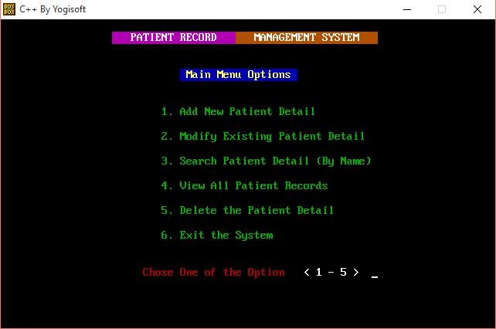**a) Main Menu Screen:**

Figure (4.1): Main menu screen of patient record management system

The main menu screen of the patient record management system is shown in the above figure (4.1) . The main menu of the patient record management system includes following options:

1. Add new patient detail
2. Modify existing patient detail
3. Search patient detail (By Name)
4. View all patient records
5. Delete the patient detail
6. Exit the system

Figure (4): Main Menu screen of Patient Record Management System

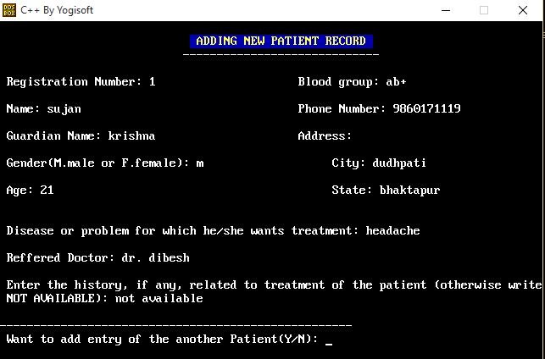**b) Adding new patient detail:**

Figure (4.2): Adding new patient detail

On choosing the option <1> from the main the screen of the system, the user can add the new details of the patient to the file.

The user is asked to enter the details of patients as shown in the figure above. After finishing the entry of details of the patient, the system asks user if he/she wants to add another patient’s detail. Depending on the option chosen by the user, the user goes back to the main menu screen or adds another patient detail.

Figure (5): Adding new patient detail

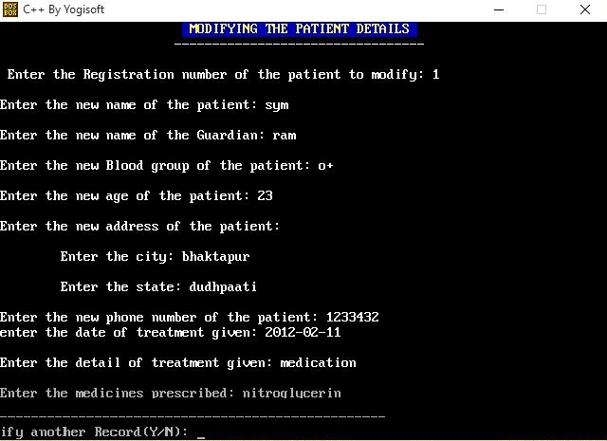**c) Modify existing patient detail:**

Figure (4.3): Modifying existing patient detail

On choosing the option <2> from the main screen of the system, the user can modify/change the existing detail of the patient.

Firstly, the user is asked to enter the patient registration no. of whose detail is to be changed. After receiving the patient registration no., the system asks new patient detail in order to modify the previous details of the patient and add the treatment record to the patient detail. After all the new data are received by the system, the system asks the user if he/she wants to modify another record as shown at the bottom of figure (6). If the user gives ‘y’ as input, then the user can modify another patient record and if the user gives input other than ‘y’, then the system returns to the main menu screen.

The figure (4.3) is the modified detail of the patient whose previous detail is shown in the figure (4.2).

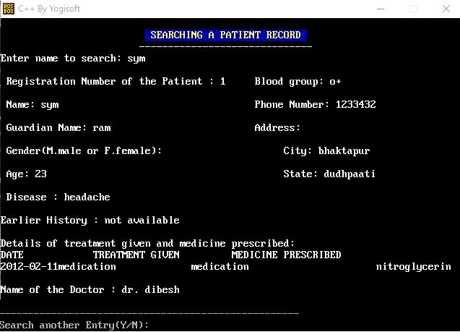**d) Search patient detail (By name):**

Figure (4.4): Searching the patient detail

On choosing the option <3> from the main menu screen, the user can search the patient detail of specific patient by their name.

On entering the search patient detail option, the user is asked to enter the name of patient for searching and displays the detail of the patient if found. After displaying the detail of the patient, the system asks user if he/she wants to search another patient detail. ). If the user gives ‘y’ as input, then the user can search another patient record and if the user gives input other than ‘y’, then the system returns to the main menu screen.

Figure (7): Searching the patient detail

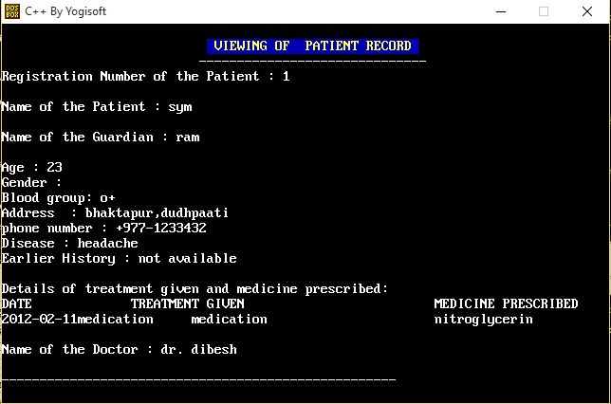**e) View all patient detail:**

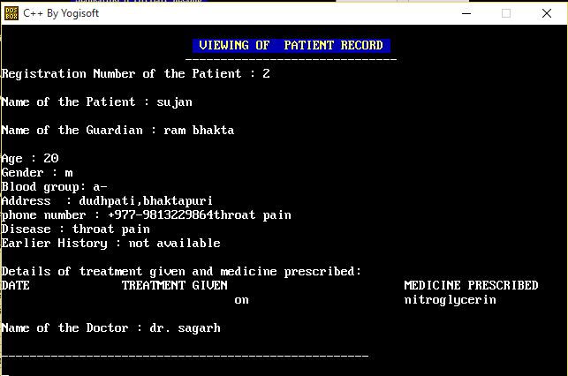

Figure (4.5): Displaying detail of the patient

Figure (4.6): Displaying next detail of the patient

On choosing the option <4> from the main menu screen of the system, the user can view all the records of the patients.

The system displays the records of the patients recorded in the file one by one. After the system displays the one patient’s detail from the file, the user need to press a key from the keyboard in order to view the next record of patient’s detail stored in the file.

Figure (4.5) is the first record displayed from the file and on pressing the key from the keyboard, the system displays the next record i.e. figure (4.6).

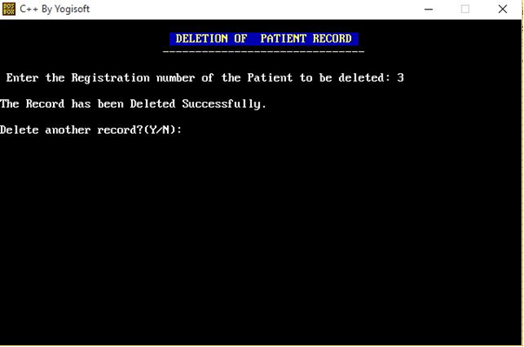**f) Delete the patient detail:**

Figure (4.7): Deleting detail of the patient

On choosing the option <5> from the main menu screen of the system, the user can delete the specific record of the patient. To delete the record, the user has to enter the registration number of the patient and if the record is present then the detail of that patient is deleted and the information that delete was successful is shown in the screen.

**4.2 Tasks accomplished:**

The tasks accomplished in creating patient record management system are

1. Function to add patient details
2. Function to modify the patient details
3. Function to search patient details by name
4. Function to view all patient details
5. Function to delete the record of the specific patients,

**CHAPTER 5**

**CONCLUSION AND RECOMMENDATION**

**5.1 Conclusion:**

We developed a simple patient record management system studying different types of the record keeping system. The record management system need to have the function of adding new details to the file, modifying the existing details, searching the details stored in the file, deleting the details stored in the file and many more. Therefore, keeping these functions in mind, we have developed the patient record management system.

**5.2 Future Recommendation:**

There can be made many improvements in the system we developed. Some of the future recommendation to make the system qualitative are:

* Add login security to secure the records.
* Add patient billing system.
* Make the system more user friendly using graphics design.

**REFERENCE**

1. “Hospital Management System Video”, [http://www.youtube.com/watch?v=7bclZEpbT 3M&t=188s](http://www.youtube.com/watch?v=7bclZEpbT%203M&t=188s) [Visited date:- 2017-01-05]

2. “Patient record management system project sample”, <https://sourceforge.net/projects/pa> tientms/ [Visited date:- 2017-01-05]